CHIRICAHUA APACHE MIMBRENO NDE NATION
TMF-2018
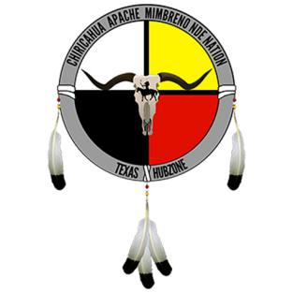
TRIBAL MEMBERSHIP FORM

NAME: ADDRESS:

First: Street:

Middle: Apt#:

Native: City:

Last: State:

Zip Code:
Phone:

Email: DOB:

Driver’s License State: DNA Submitted? (Y/N):

Driver’s License #: LiveScan Submitted? (Y/N):

Sex: Membership Type ():

Height: Silver ($350) Gold ($700)

Weight: Fee Paid w/PayPal Online (Y/N)?:

Hair: Signature:

Eyes: Date:

Please mail this form to:
CAMN Nation, 16738 Lakeshore Dr Suite H48, Lake Elsinore, CA 92530

You can also email this form to: ApacheMimbrenoNation@gmail.com

